**December Monthly Report**

Zihan Qiao (Weibo)

**The workflow of Weibo in November**

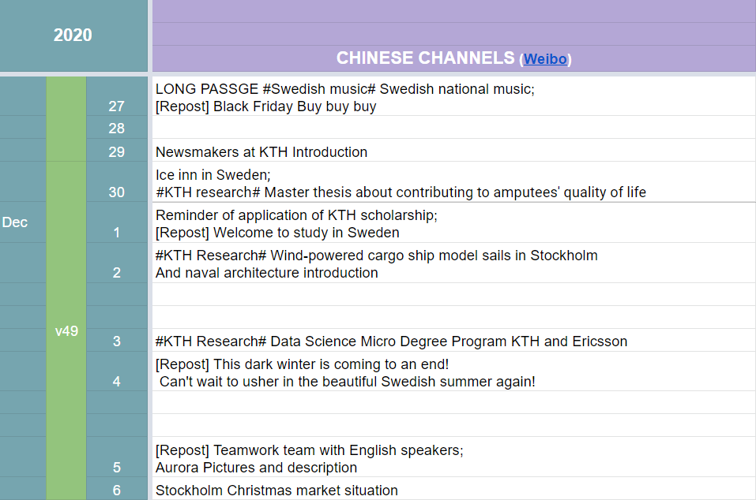

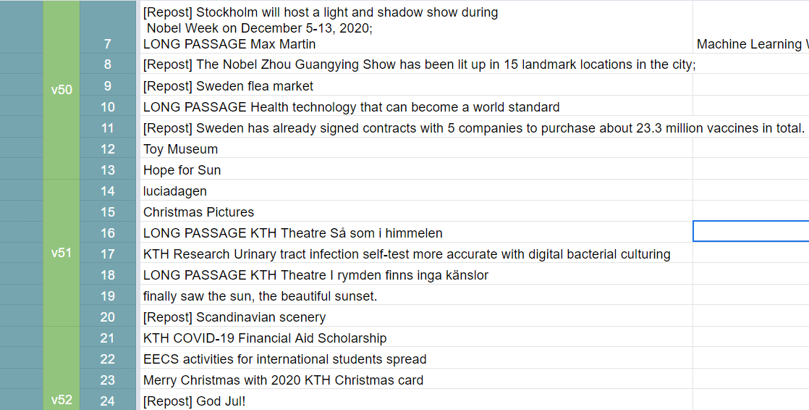

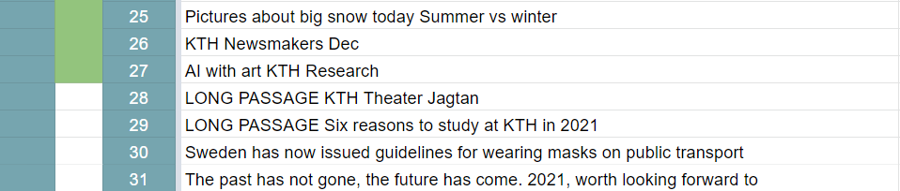

Figure 1 Content Sheet for December

**Statistics**

The number of long passages: 6;

Missed days: 0;

On 2020/12/1, there are 23643 followers.

On 2021/1/2, there are 25465 followers.

There are 1822 new followers in one month.

**Shining point:**

1. The application FAQ continuous updating and pinned to the top;
2. Write three passages about Swedish movies, including Jagtan, Så som i himmelen, I rymden finns inga känslor.
3. About Swedish songs, write a passage about Max Martin.
4. Write many KTH latest research introductions.
5. Six reasons you should choose KTH, which is nice for Chinese potential applicants.

**Weaknesses:**

1. Still few Vlogs.

**December Plan Check:**

~~Christmas pictures~~

~~Trying to answer more questions about application~~

**Personal feelings**

Get very comfortable and skilled in operating the Weibo.

Writing time: 2021/1/2